1.Project name: Fast&Easy

2.Team Members: Aidana Assylkhan, Baglan Duisek, Korobeinikova Aleksandra, Bozachidi Ekaterina.

3. List of participants:

• product manager

• Project Manager

• strategic planning manager

• financial analyst

• manager of logistick

• operations manager

• internet marketer

• traffic marketer

• web analyst

• customer service manager

• business analyst

• Content manager

• Web Designer

• online merchandiser

• email marketer

• site administrator

• online platform manager

4.

1. **Requirements**

First, we need to define project requirements. Main requirements are following:

* Fully automated store without cashiers or terminals
* Fully operating application giving the information of purchases and payment
* Recording system (camera and sensors) with no errors in a given situation
* Possibility to pay with local government recognizing currencies and methods

1. **Design**

Researching the market for currently available CCTV hardware and software, and magnetic, electromagnetic sensors which can be applied to all sort of goods in grocery stores.

1. **Implementation**

We are choosing python language for coding language, because it is agile, easy to use, object-orientated which suits to our requirements. In this phase, we should build software, databases and mobile applications. Main challenge is to correctly connect recording system to software.

1. **Testing**

The key part of development- testing. We need to check if application is working correctly, do recording system mistakenly remove or add items to purchase list, if billing functions precise etc.

All kind of case scenarios should be played to ensure safety and correctness of purchase process

1. **Maintenance**

After all above mentioned phases are successfully done, final phase is maintenance- maintaining code, adjusting if necessary; securing databases; reviewing and checking financial operations

6. The diagram demonstrates basic software architecture of the project. First of all, customer has to create account and provide necessary information such as name, email address, phone number and data of bank credit or debit card. That will give customers access to grocery and its services.

The customer may replenish account with any bank debit or credit card. Moreover, it may deposit cash directly into his account, this will instantly update account balance.

The moment customer enters the shop and pick up item, software will place order which includes all the goods customer has in its basket. After customer leaves store, all items which have been sold will be delivered to transaction process where certain amount of money will be withdrawn from the account balance and transaction check will be placed in transaction history.

Broker may place a order, its data will be processed through Stock Exchange Center

7.

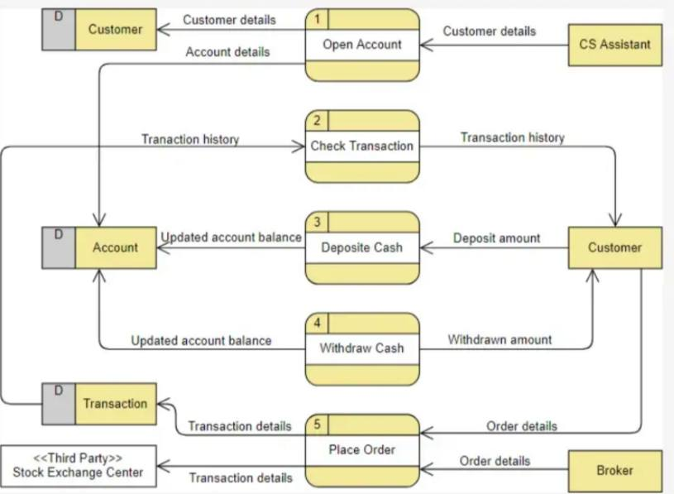

8.

https://www.figma.com/file/0fIQAmxJrDqlve7bPS1IPo/Untitled?node-id=0%3A1&t=zv6UJbH6uprvjy9B-0

9.

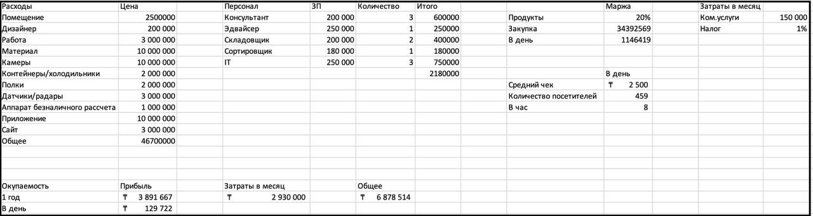

Оборудование:

1. Камеры - 5 000 000 тг /100 камер.
2. Контейнеры/холодильники - 2 000 000 тг.
3. Полки - 1 000 000 тг.
4. Датчики/радары - 3 000 000 тг.
5. Аппарат безналичного расчета - 1 000 000 тг.